**ST. XAVIER’S COLLEGE**

**MAITIGHAR, KATHMANDU**



**DBMS**

**Lab Assignment**

**Submitted by:**

Anu Kadel

013BSCIT007

**Submitted to:**

|  |  |
| --- | --- |
| **Er. Sanjay Kumar Yadav** |  |

Lecturer

Department of Computer Science

St. Xavier’s College, Maitighar

**CREATE A TABLE ‘DEPRTMENT’**

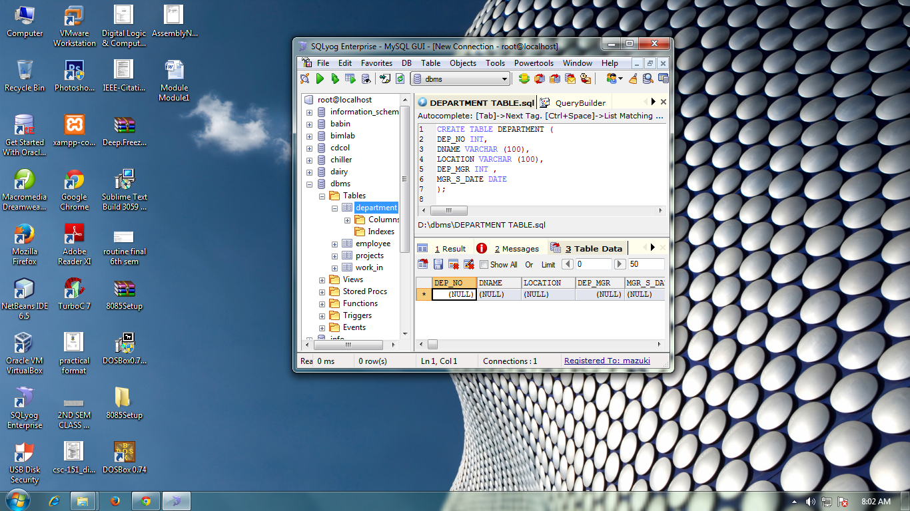

**INSERT VALUES IN DEPARTMENT**

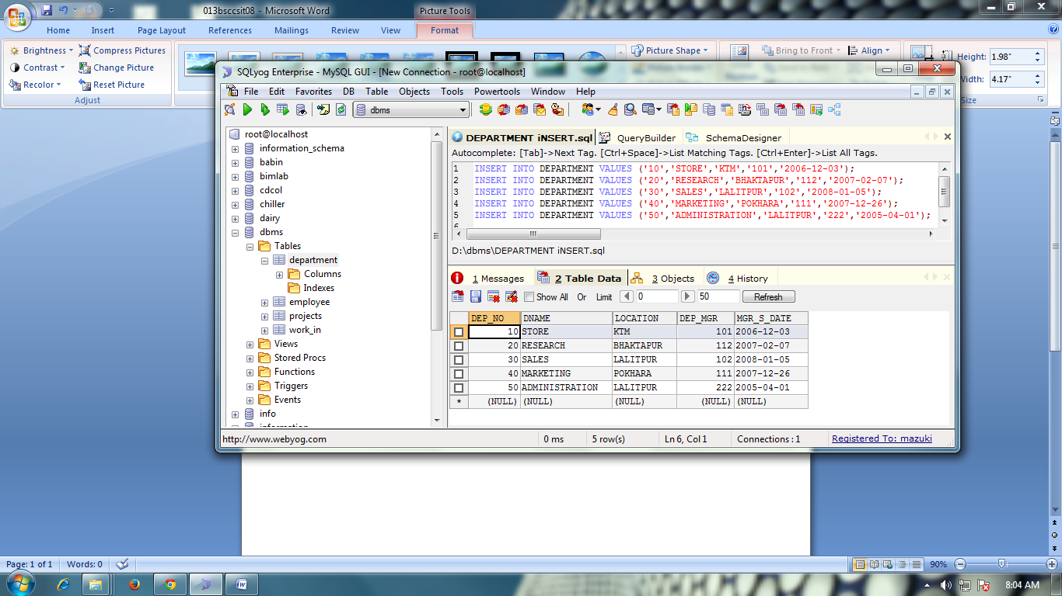



**CREATE TABLE EMPLOYEE**

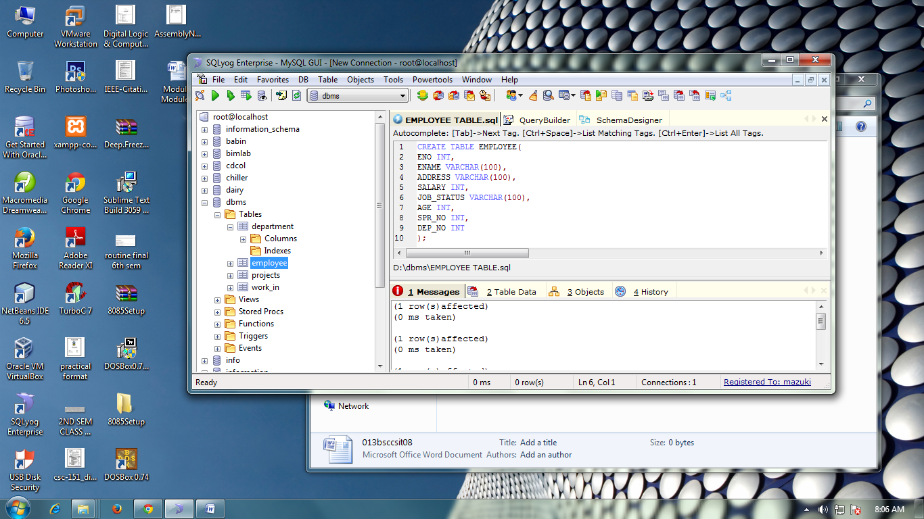

**INSERT VALUES IN EMPLOYEES**

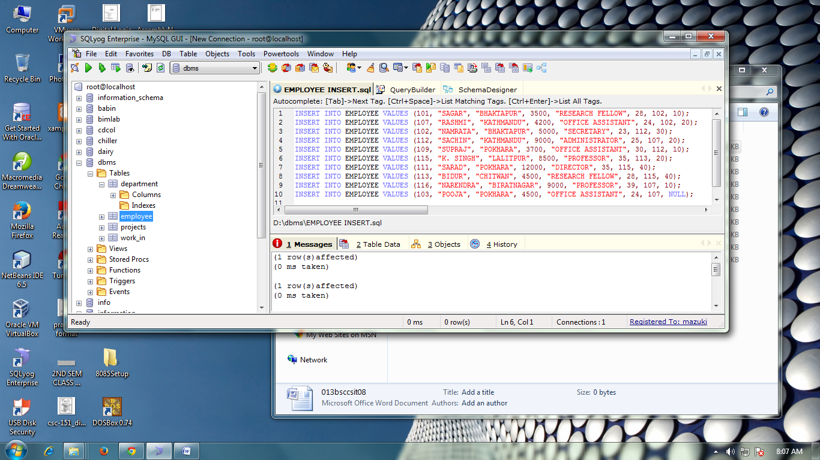

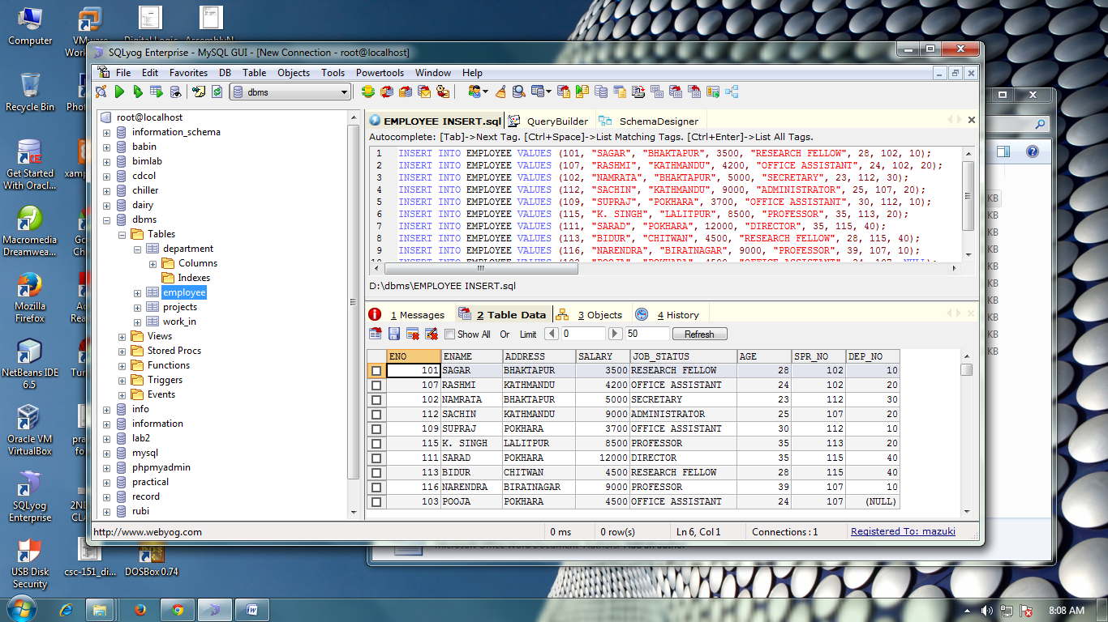

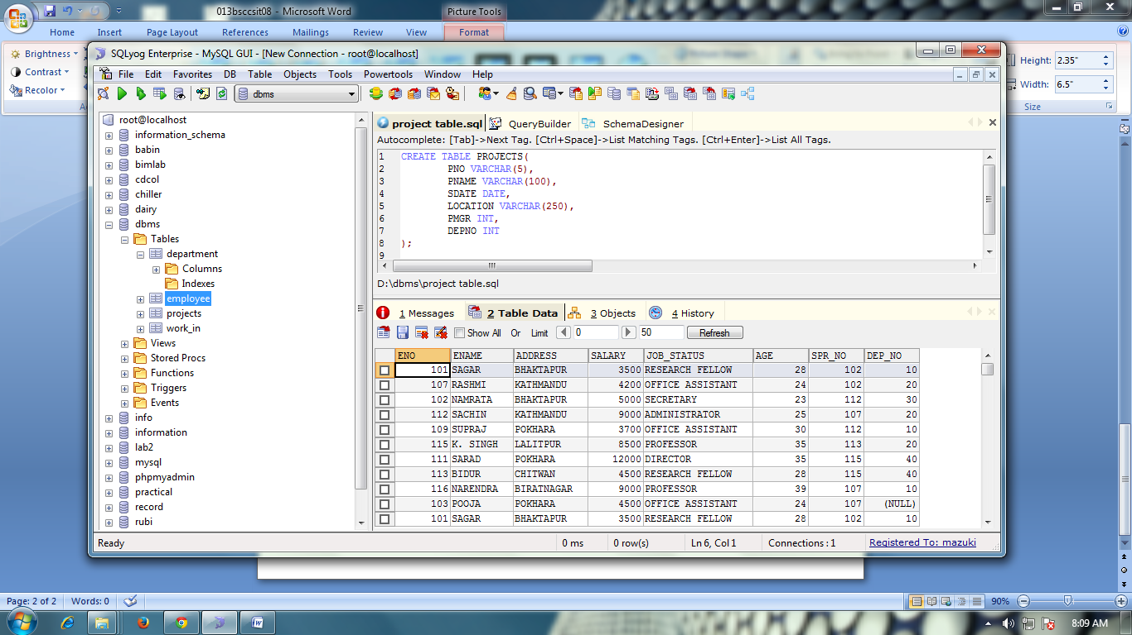

**INSERT VALUES IN PROJECTS**

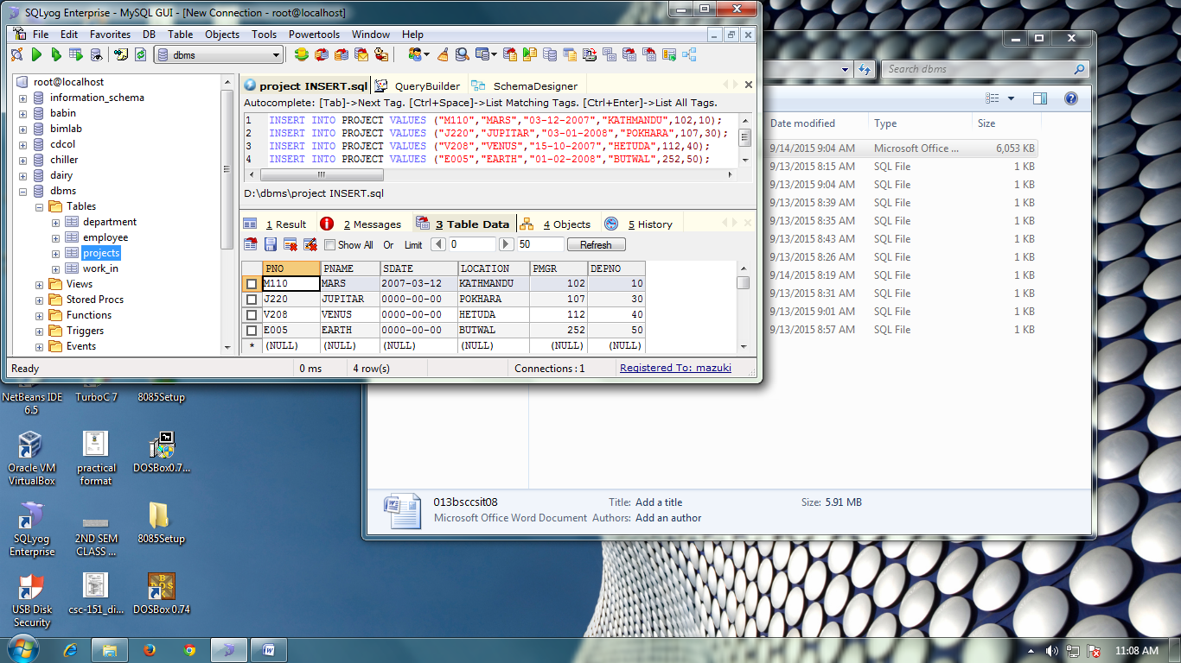



**CREATE TABLE WORK-IN**

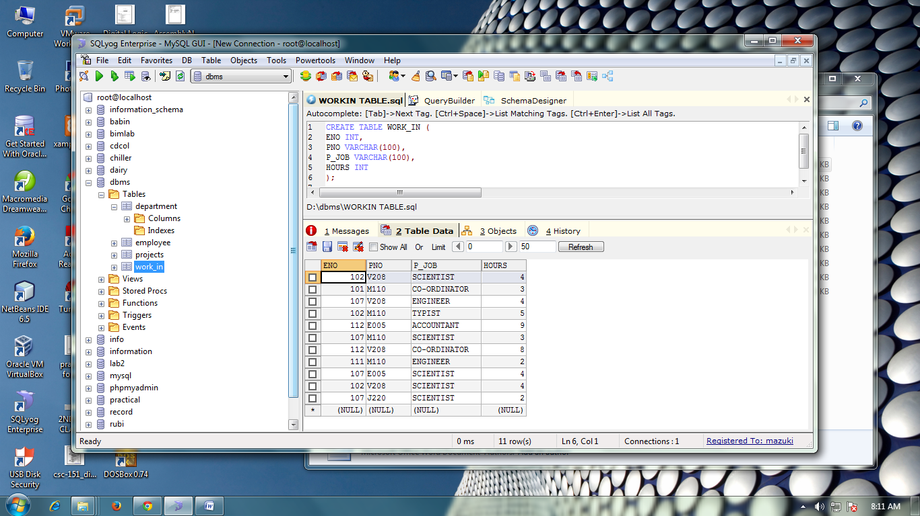

**INSERT VALUES IN WORK_IN**

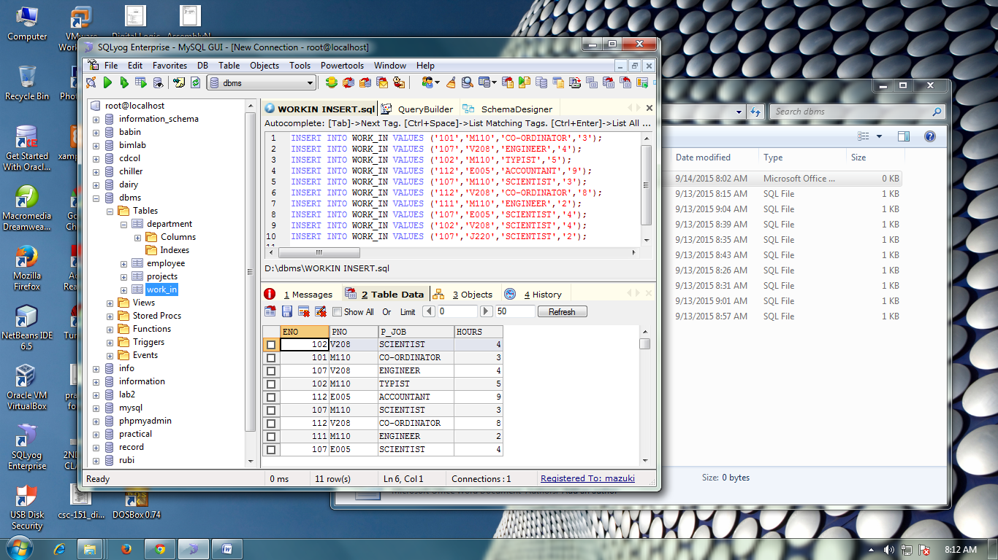

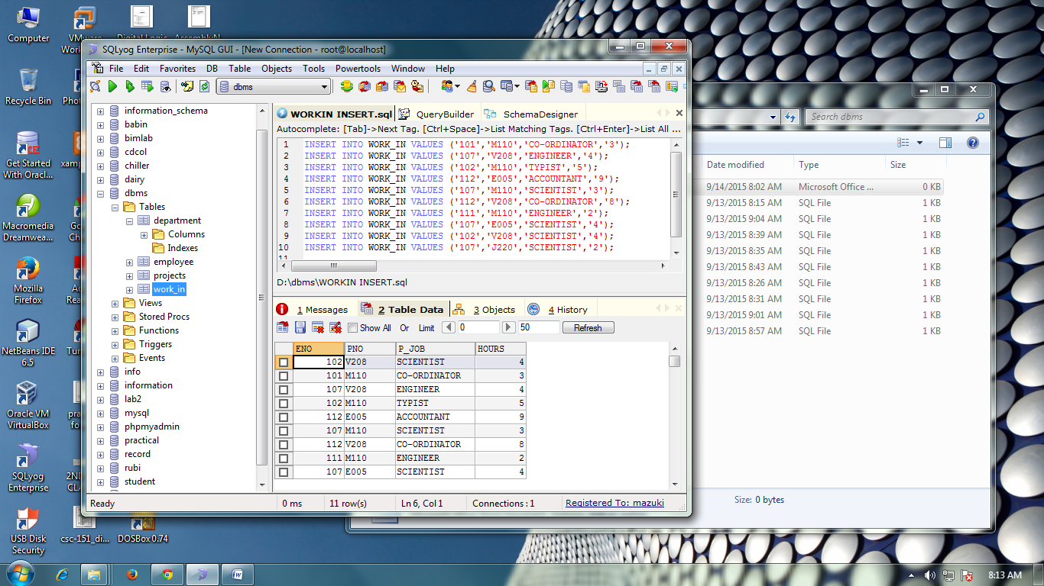

**FIND THE ENO, ENAME OF THE EMPLOYEE WHOSE SALARY IS GREATER THAN 4000.**

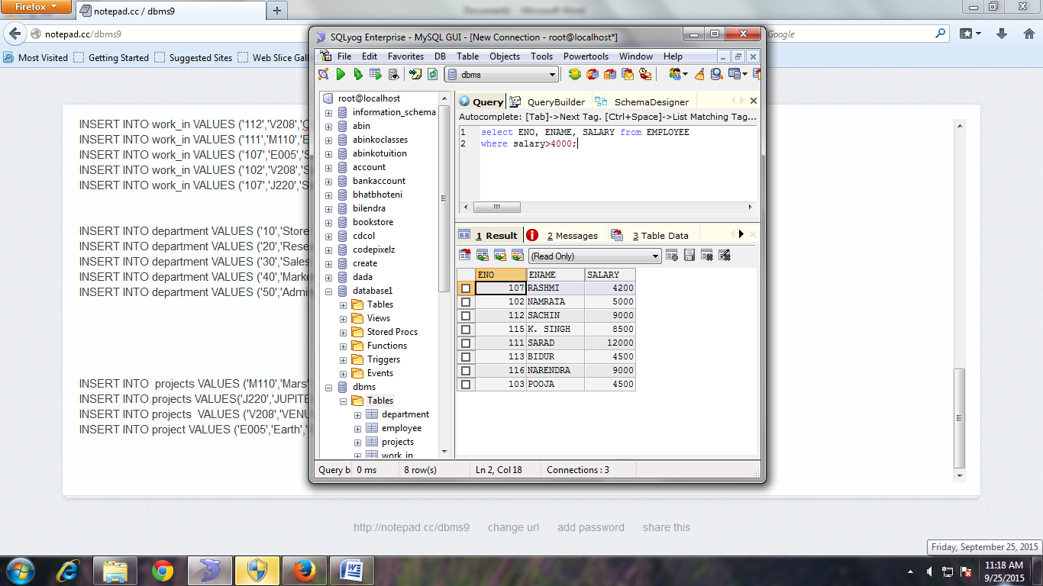

**FIND THE ENO, ENAME, SALARY OF THE EMPLOYEES WHOSE SALARY IS GREATER THAN 5000 AND JOB STATUS IS PROFESSOR [COMBINING CONDITIONS AND BOOLEAN OPERATIONS]**

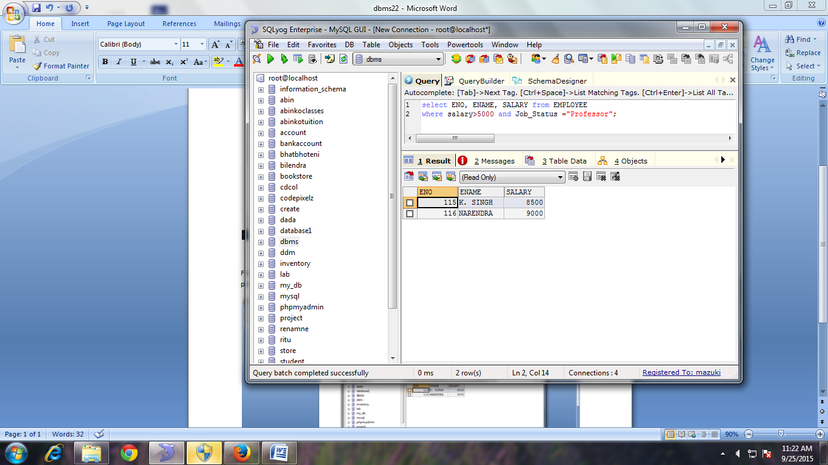

**SELECT ADDRESS FROM EMPLOYEE [ REMOVING DUPLICATE]**

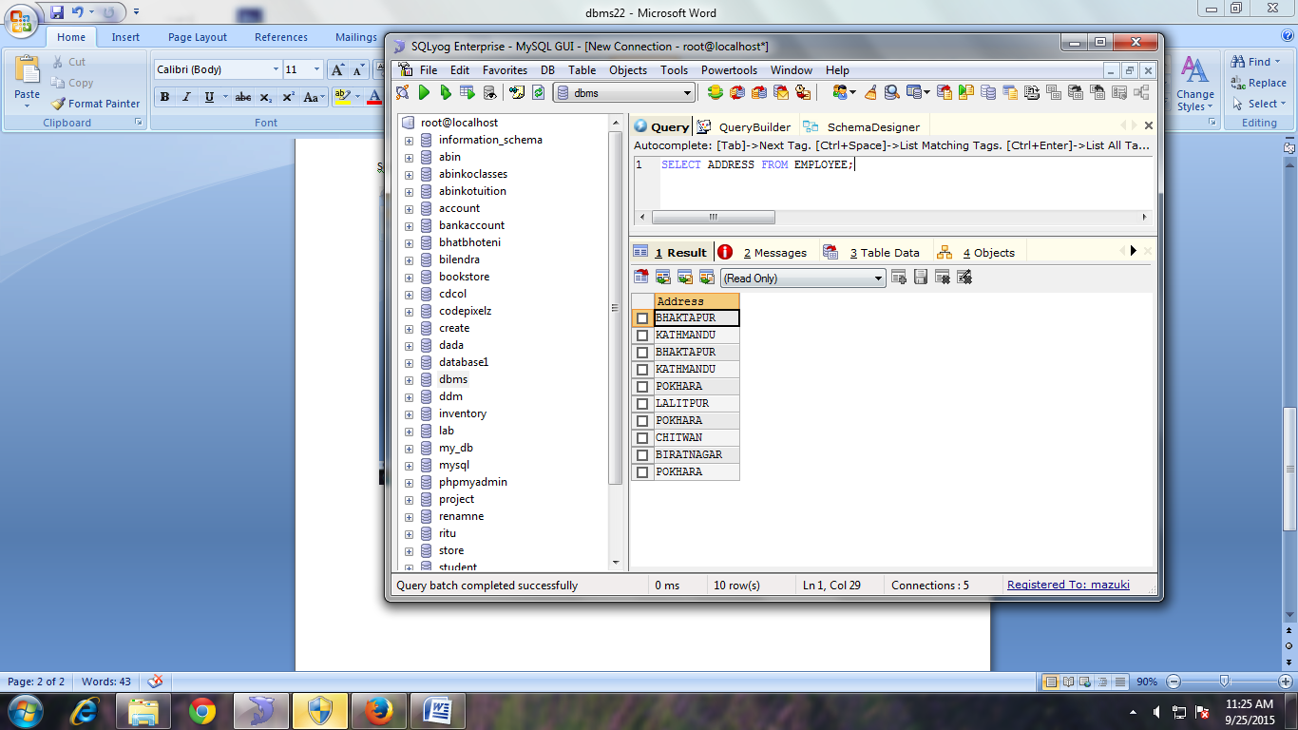

**SELECT DISTINCT ADDRESS FORM EMPLOYEE**

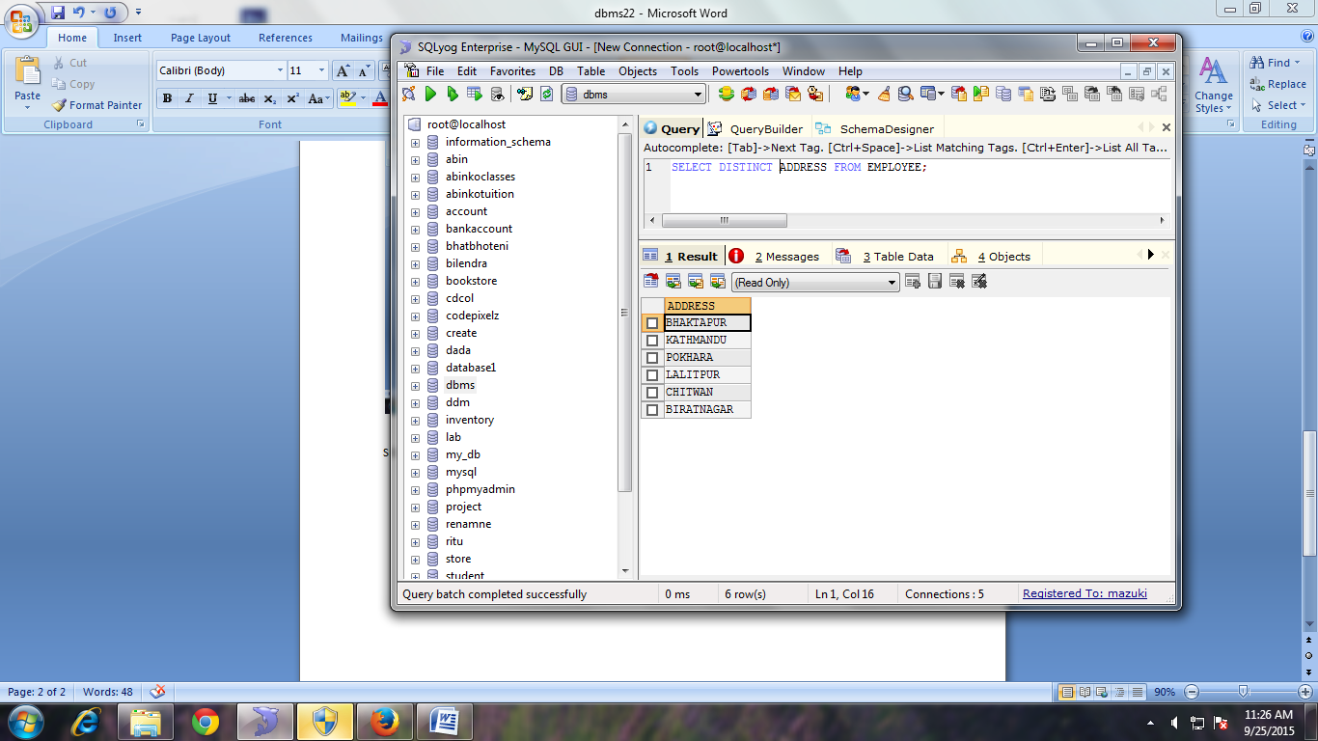

**FIND THE ENO, ENAME, SALARY OF THE EMPLOYEE WHOSE DEPARTMENT NO 20 OR JOB_STATUS IS RESEARCH FELLOW.**

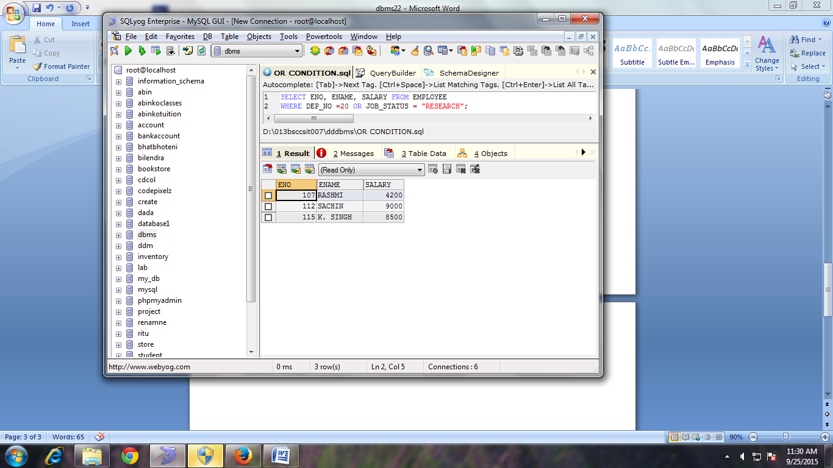

**FIND THE ENO, ENAME, AGE, AND SALARY FROM EMPLOYEE WHERE AGE IS BETWEEN 24 AND 28. [RANGE SPECIFICATION (IN AND BETWEEN)]**

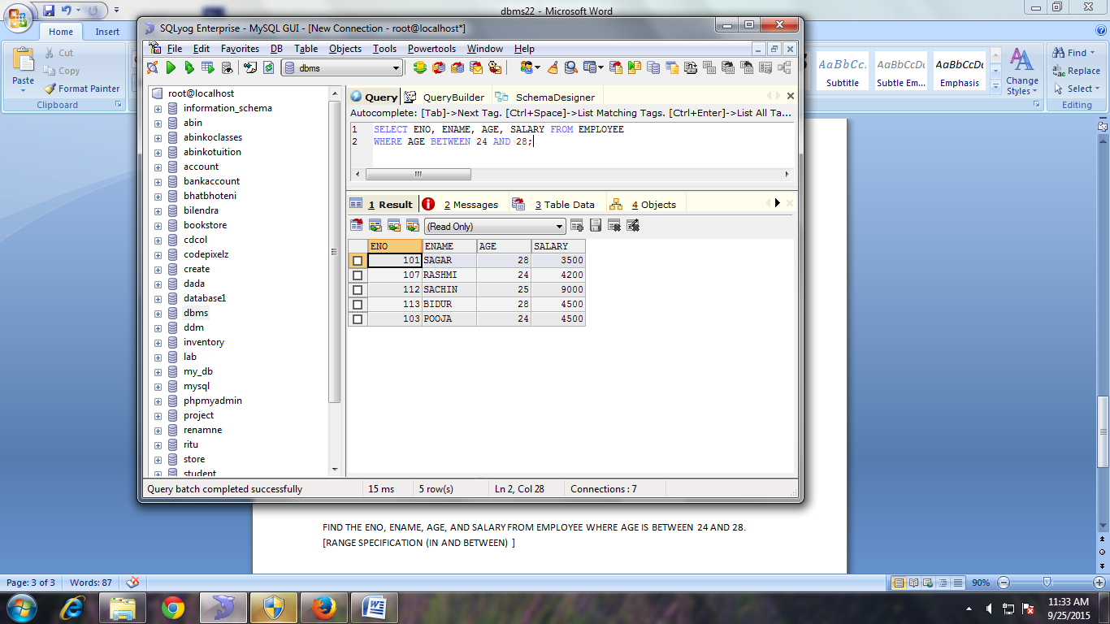

**STRING OPERATION**

**ABC%** :

All strings that start with ABC.

Example ;ABCD and ABCDABCD would both satisft the condition.

**%XYZ:**

All string that end with XYZ.

Example: WXYZ and ZZXYZ would both satisfy the condition.

**%AN%**

All string that contain the pattern **AN** anywhere.

Example: LOS ANGLES and SAN FRANSCISCO.

**FIND ENO, ENAME WHOSE STARTING LETTER ‘SA’.**

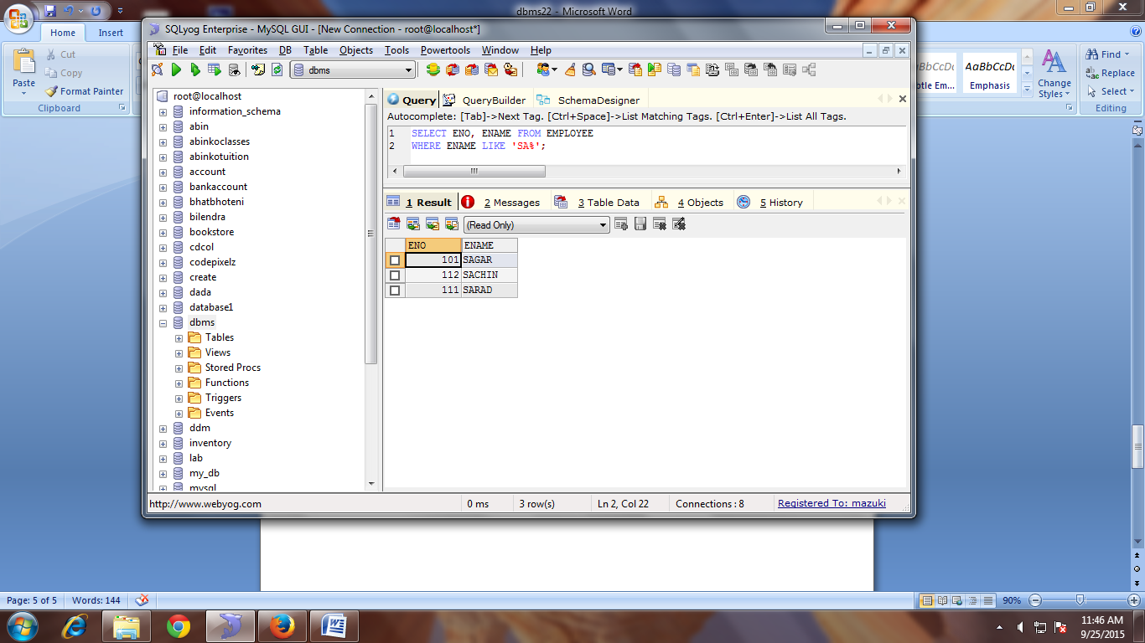

**LIST ALL EMPLOYEES’ NAME WITH THEIR PROJECT NAME**

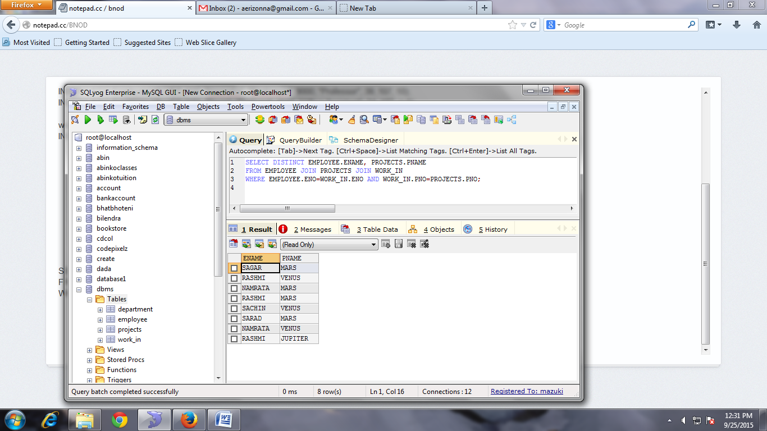

LIST NAME OF ALL EMPLOYEES AND THEIR SALARY WHO ARE WORKING IN PROJECT MARS OR VENUS

LIST NAME OF ALL EMPLOYEE AND SALARY WHO ARE WORKING IN PROJECT EARTH AND VENUS

LIST NAME AND ADDRESS OF ALL EMPLOYEES WHO WORKS IN DEPARTMENT WHICH IS LOCATED IN POKHARA.